**DAILY ONLINE ACTIVITIES SUMMARY**

|  |  |  |  |  |  |  |  |
| --- | --- | --- | --- | --- | --- | --- | --- |
| **Date:** | **02 June 2020** | | | | **Name:** | **K ISHA HEGDE** | |
| **Sem & Sec** | **4th sem, 2nd year** | | | | **USN:** | **4al18cs031** | |
| **Online Test Summary** | | | | | | | |
| **Subject** | | **--** | | | | | |
| **Max. Marks** | | **---** | | **Score** | | **-----** | |
| **Certification Course Summary** | | | | | | | |
| **Course** | **Robotics process automation** | | | | | | |
| **Certificate Provider** | | | **GUVI** | **Duration** | | | **3 hours** |
| **Coding Challenges** | | | | | | | |
| **Problem Statement:3 program** | | | | | | | |
| **Status: Executed** | | | | | | | |
| **Uploaded the report in Github** | | | | **Yes** | | | |
| **If yes Repository name** | | | | [https://github.com/iishaii/locked-down_coding](https://github.com/iishaii/locked-down_coding" \o "https://github.com/iishaii/locked-down_coding)  <https://github.com/keertanaganiga/lockdown_reports> | | | |
| **Uploaded the report in slack** | | | | **Yes** | | | |

**Certification Course Summary:** **Today I started new certificate course through GUVI ,**

**ROBOTICS PROCESS AUTOMATION .It was three hours course. I also secured a certificate.By the end of the session I was able to:**

* **Describe robotic process automation**
* Describe the impact of RPA on the future work
* List the benefits of RPA.
* Understand a robot & it's types.

The topics covered are:

* 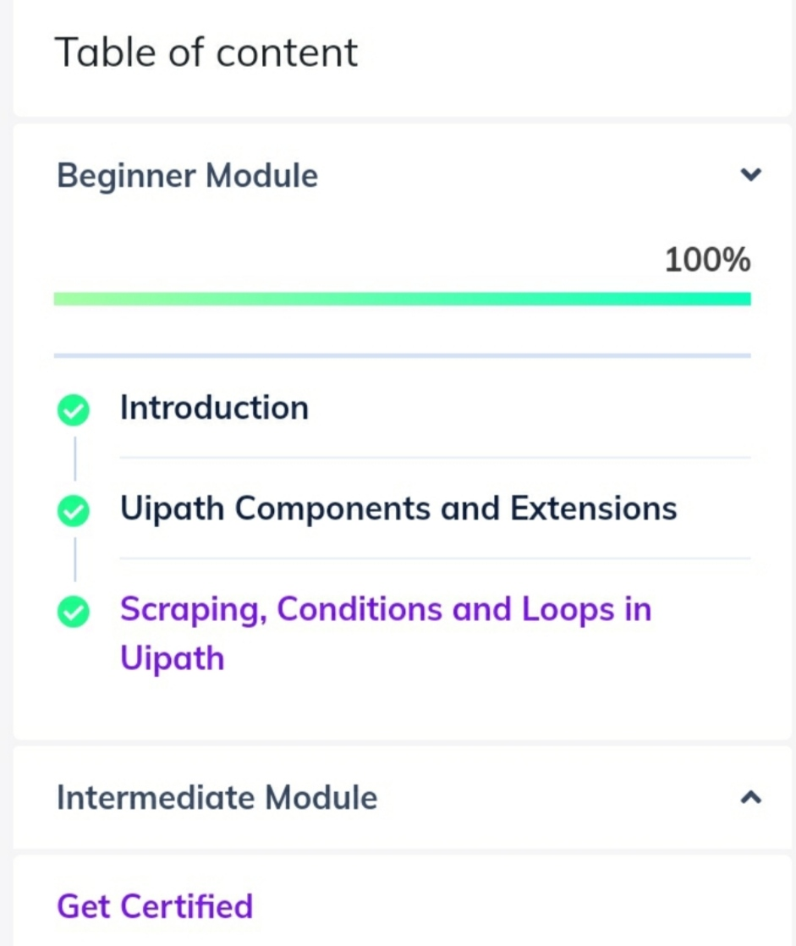

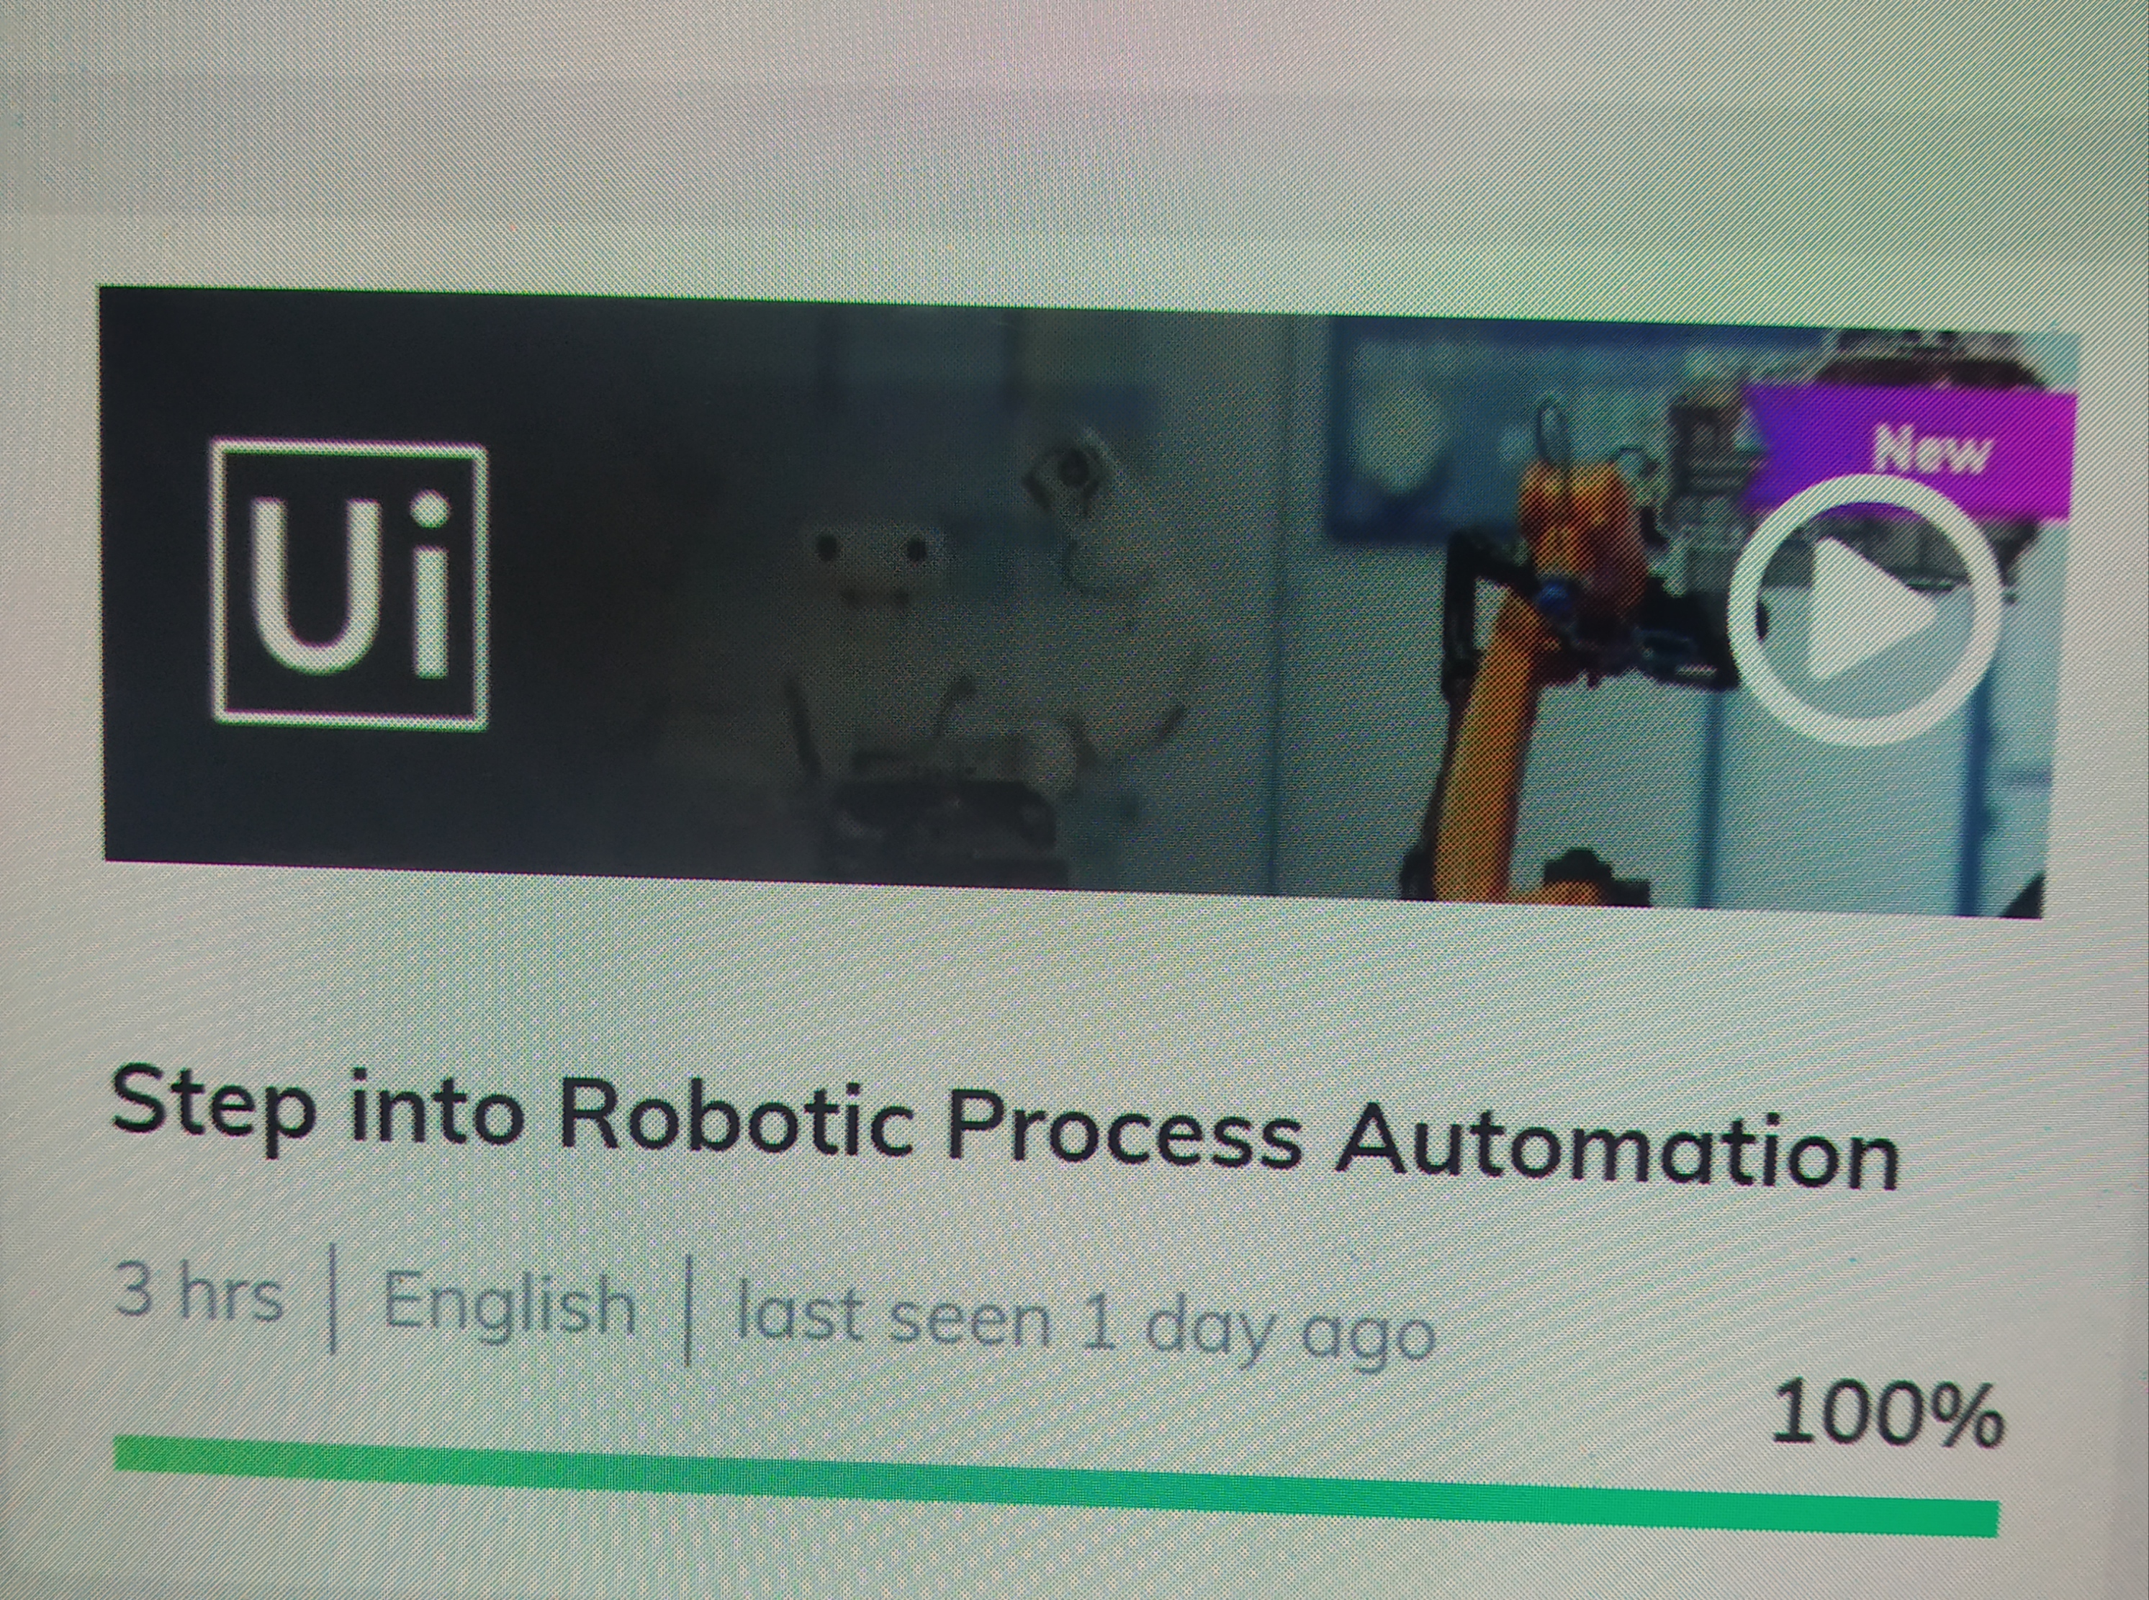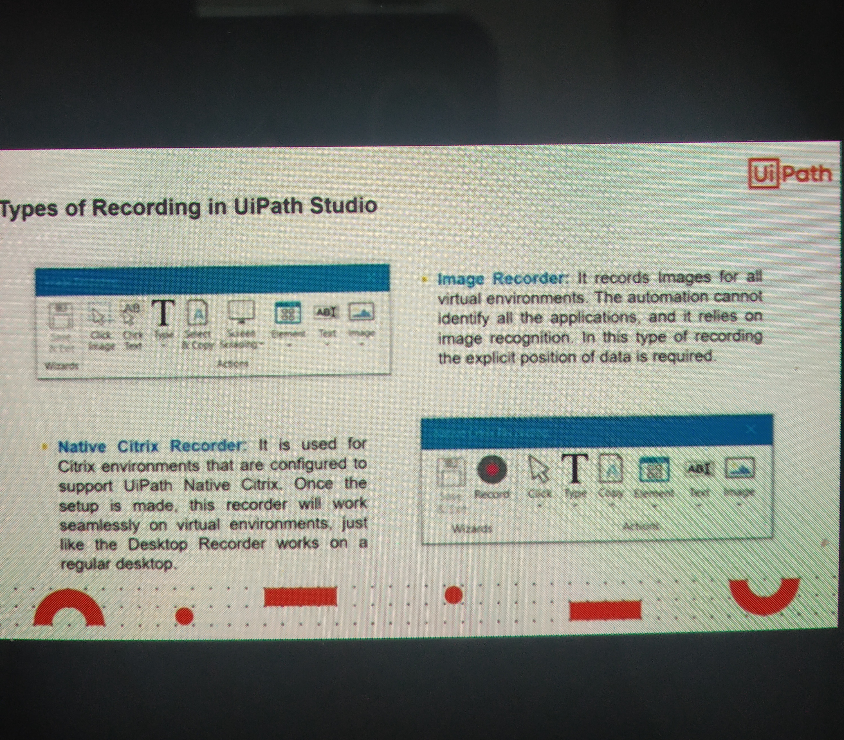



**Coding Challenges:**

Today I solved 3 coding challenge,

1. **Given an array of positive integers. Write a C Program to find inversion count of array.**
2. **Write a Java program to find Perfect Sum Problem**
3. **Write a program in java, an array of integer data to be initialized. During the initialization, if a user enters a value other than integer value, then it will throw InputMismatchException exception. On the occurrence of such an exception, your program should print “You entered bad data.” If there is no such exception it will print the total sum of the array.**

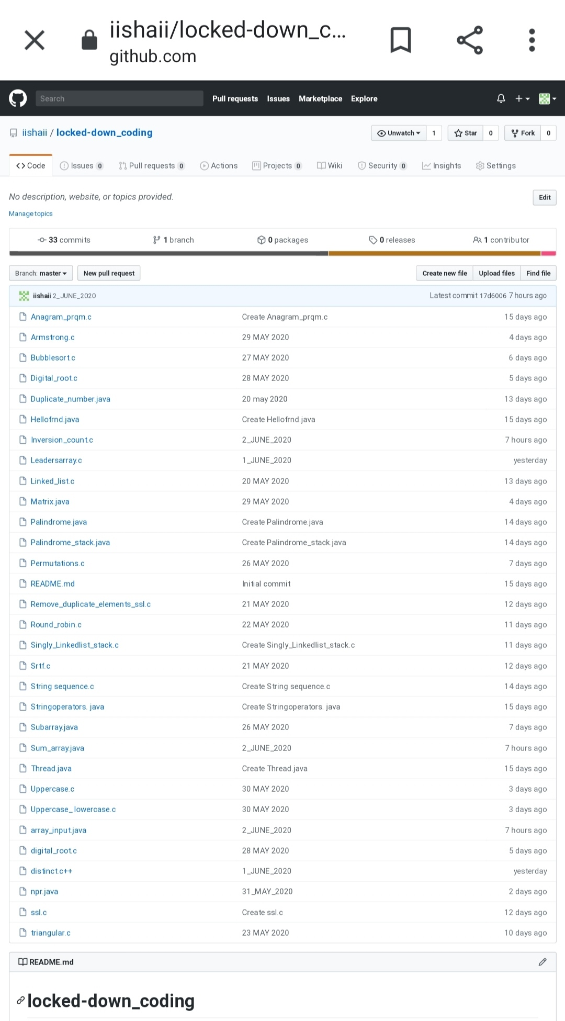

The solution is uploaded in GitHub

[https://github.com/iishaii/locked-down_coding](https://github.com/iishaii/locked-down_coding" \o "https://github.com/iishaii/locked-down_coding)